WEC Development Project
Winter Semester 2025/2026
Final Design Report

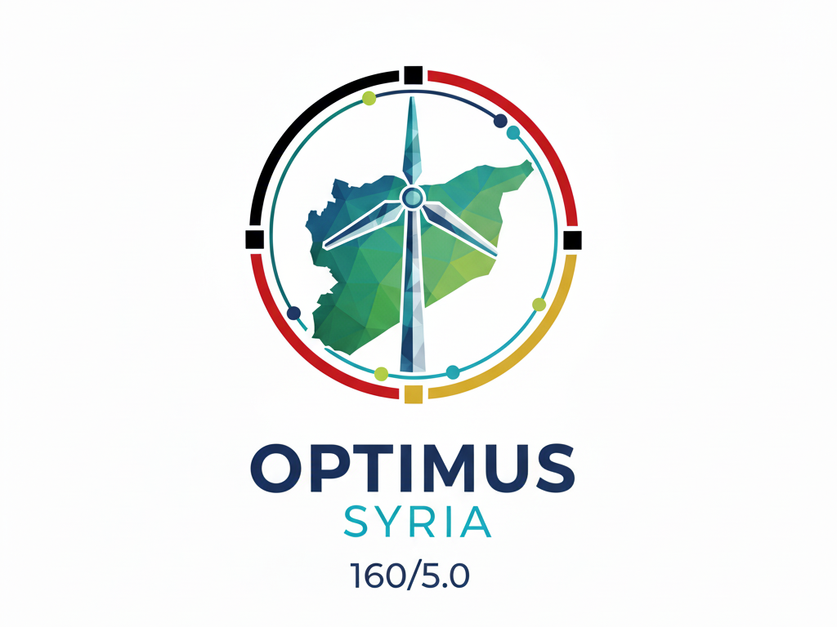

Project Name: Optimus Syria
Sub Project: ex: MDT, PD, EDT ,RTS….
Authors: | Matriculation number:
Member name  Member name | ….  ….

Supervisor:
(Your Supervisor)
Date: 10.11.2025

Table of contents

Table of contents III
Abstract : A single paragraph (150-300 words). IV
List of abbreviations V
List of symbols VI
List of Figures VII
List of Tables VIII
1. Introduction 1
2. [Title placeholder] 2
2.1 [Title placeholder] 2
2.1.1 [Title placeholder] 2
References 3
Appendix 4

Abstract : A single paragraph (150-300 words).

List of abbreviations

[Placeholder for abbreviations]
[Examples from Engineering/Reports:
- WEC: Wind Energy Converter
- MDT: Mechanical Drivetrain Team
- PD: Power Distribution
- HVAC: Heating, Ventilation, and Air Conditioning
- CAD: Computer Aided Design]

List of symbols

[Placeholder for abbreviations]
[Example:
- $ρ$ (rho): density ⁴ (Units: kg/$m^{3}$)
- $ω$(omega): angular velocity (Units: rad/s)
- $C_{p}$: Power Coefficient (Units: dimensionless)
- P: Power (Units: W or kW)
- T: Torque (Units: N . m)]

List of Figures

List of Tables

1. Introduction

2. [Title placeholder]

2.1 [Title placeholder]

2.1.1 [Title placeholder]

References

Appendix

